|  |  |
| --- | --- |
| TEAM PROJECT S2 2024 Final  Word count: 2741  BUSA6430 – Business Application of AI  Tutor: Barak Alkhaldi (Thursday – 5pm) | Group Members  Khuat Son Tra Nguyen - 48144134  Quoc Trung Nguyen - 48299405  Kuan-Yin Lin - 48054798  Ngoc Tram Tran - 47753595 |

Table of Contents

1. Business Concept 2

1.1 Name and Description 2

1.2 Target Audience 3

2. Use of GAITs 5

2.1 Internal Use 5

2.2 Customer use 6

2.3 Collaboration 6

2.4 Data Privacy 6

3. Business Model 8

3.1 Revenue Stream 8

3.2.1 Primary Revenue: University Partnerships 8

3.2.2 Secondary Revenue: 9

3.2 Marketing Strategy 9

3.2.1 Long-Term Strategic Objectives 2024-2027 9

3.2.2 Targeted Strategies 10

3.2.3 Customer Journey 11

4. Implementation Plan 13

4.1 Launch Strategy 13

4.1.1 Initial Steps 13

4.1.2 Key Milestones: 13

4.2 Challenges & Solutions 14

5. Evaluation 16

5.1 Success metrics 16

5.2 Feedback Mechanism 17

References 18

# 1. Business Concept

## 1.1 Name and Description

**StudyPaws**



**StudyPaws**, our business, is an innovative pre-arrival and ongoing support service designed initially for international postgraduate students planning to study in Australia given that research shows these students face persistent challenges that have remained largely unchanged for over two decades (Oduwaye et al., 2023).

To begin the journey with StudyPaws, our clients will be offered a comprehensive **Welcoming Package**, providing research-backed pre-arrival support (Parsons, 2000) that covers life essentials (housing assistance, visa regulations, workplace guidance), financial wellness (budgeting, fraud protection), and academic preparation (research culture, expectations). Universities can monitor student progress and customise content to meet their specific needs.

Following initial orientation, students receive ongoing support through **AI Virtual Pet Companions**, which help to address key challenges identified by Forbes-Mewett and Sawyer (2011): language barriers, independent living challenges, and socio-cultural adaptation. These desktop-based companions provide culturally sensitive emotional and practical guidance throughout the student's journey.

Furthermore, the service is specifically tailored for international postgraduates, addressing the unique challenges of career-oriented professionals returning to academia. Our **virtual pets** deliver targeted networking and career development resources, responding to postgraduates' strong interest in Personal Development Planning (Baker et al., 2014)-alongside essential research support and long-term budgeting tools. This comprehensive approach meets the distinct needs of independent professionals transitioning back to study, from academic writing to financial planning.

**Our competitive advantage** lies in providing immediate, zero-step emotional support through AI companions that proactively check in on students and detect signs of distress, addressing the reduced accessibility of university counselling services noted by Scott (2024). Early-stage homesickness and isolation challenges (Shah et al., 2019) are met with culturally appropriate support, while language barriers, identified as a primary challenge by Oduwaye et al. (2023), are addressed through multilingual support options.

Unlike traditional support services, our approach combines practical guidance with emotional support, delivered through engaging virtual pets that make mental health support both accessible and culturally acceptable. The AI companions seamlessly connect students to professional help when needed, creating a comprehensive support system that adapts to students' language preferences and cultural backgrounds while maintaining professional standards of care.

## 1.2 Target Audience

* **International Postgraduate Students** (and potentially international undergraduates) in Australia
* **Educational Institutions**: Australian universities and colleges seeking cost-effective and innovative support solutions for their students

**For International Students.** StudyPaws addresses persistent challenges through immediate emotional support and practical resources via AI-powered pet companions. Our service helps students navigate pre-arrival anxiety, unfamiliarity with academic systems, housing concerns, financial difficulties, social isolation, discrimination, and labour exploitation (Martin, 2020). For postgraduates specifically, we offer specialised career development resources and Personal Development Planning support (Baker et al., 2014).

**For Educational Institutions.** With reduced support services becoming a significant concern (Scott, 2024), StudyPaws provides:

* Cost-effective, AI-based personalised support available 24/7
* Elimination of traditional barriers (social anxiety, appointment scheduling)
* Early intervention capabilities for improved student retention
* Scalable solution adaptable to both postgraduate and undergraduate needs
* Comprehensive monitoring and customization options

# 2. Use of GAITs

Our business implements **Character.ai**, **ChatGPT**, and **WithTherapy** for our virtual pet service. For internal use, **Copilot** is applied to improve workflow efficiency. The graph below provides an overview of these tools within our business service.

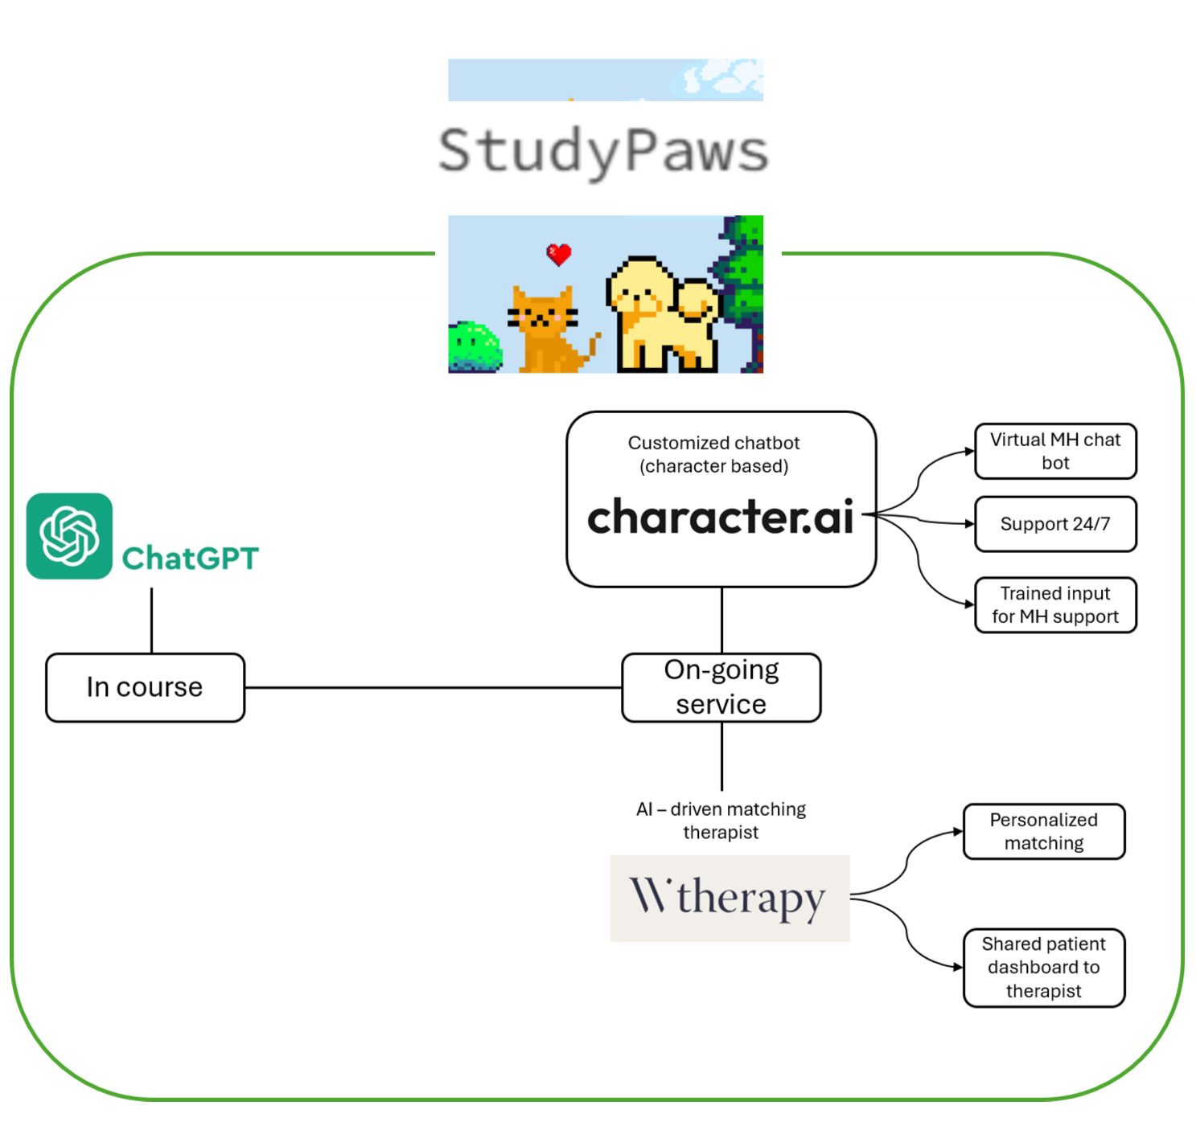

## 2.1 Internal Use

The integration of **Copilot** into our office ecosystem will serve as a virtual assistant for employees. This will automate the repetitive tasks, allowing our staff to have more time to work on strategic activities to enhance the service. The success of Copilot's implementation across industries demonstrates its effectiveness in boosting efficiency and empowering teams to focus on value-added work.

Copilot can also support analysing student engagement and identifying trends in student well-being. With these engagement metrics, Copilot will help us extract insights into students' mental health. This will enable predictive analytics to inform service improvements. With a better understanding of student well-being patterns, our team can make timely adjustments to meet students’ needs.

## 2.2 Customer use

Our virtual pet, powered by **Character.ai**, provides international students with an interactive, unique, and highly personalised mental health support service (Luna[, 2023](https://mashable.com/article/character-ai-generator-explained)). This AI tool allows each student to customise their virtual pet based on individual preferences, ensuring the pet is culturally relevant and relatable. This customisation fosters a sense of ownership and connection, enhancing the experience of our service.

During the pre-arrival course, the virtual pet serves as a learning assistant, powered by **ChatGPT**. It helps students understand the course content and provides information about life in Australia, including their rights and available support resources. This integration helps studentsgain knowledge in their new environment in an engaging and supportive way.

Our service offers ongoing support by leveraging **natural language processing** (NLP) for mental health detections (Zhang [et.al, 202](https://www.nature.com/articles/s41746-022-00589-7)2). Through daily conversations, the pet can identify when students might suffer to proactively offer support in a student's preferred language. Moreover, combining AI chatbot support and professional therapy is essential to effectively address mental health challenges ([Haque & Rubya, 2023](https://mhealth.jmir.org/2023/1/e44838)). Hence, when needed, the pet can gently suggest professional support through our integration with **WithTherapy.** This will implement **AI therapist matching**, connecting students to real therapists based on their specific needs and preferences ([Brenner, 2024](https://withtherapy.com/therapist-insights/using-ai-to-connect-you-with-the-right-therapist/)).

## 2.3 Collaboration

Our AI tools facilitate connections between students and support services. The virtual pets help create small support communities where students can share experiences and participate in group activities. Through their pets, students can set personal wellness goals and track their progress, receiving encouragement and suggestions.

The system also enables collaboration with university partners, allowing for coordinated support efforts while maintaining student privacy. This integration ensures students receive consistent support across all channels, with their virtual pet serving as a familiar, trusted interface throughout their journey. The pets can facilitate communication with university student services and help organise community events, creating a comprehensive support network that combines technological innovation with human connection.

## 2.4 Data Privacy

Data privacy is our top priority, emphasising our high commitment to protecting student data. As students’ mental health information is sensitive, the process of **data anonymisation** is implemented. Through the removal or encryption of any identifiers, students' personal information will not be linked to stored data, enhancing a **high standard of confidentiality** [(Devane, 2022)](https://www.immuta.com/blog/data-anonymization-techniques/). Notably, each stage of our AI integration and data governance practices is designed with this approach in mind, ensuring student data is protected while providing the support they need.

# 3. Business Model

## 3.1 Revenue Stream

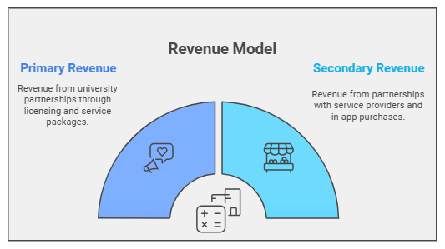

### 3.2.1 Primary Revenue: University Partnerships

* Annual/multi-year licensing
* Tiered service packages
* Customization options

StudyPaws' primary revenue stream comes from university partnerships, offering AI-powered virtual companions to support international students' mental health needs. Through annual or multi-year **licensing agreements,** universities can access tailored pre-arrival and ongoing support services, with pricing based on student enrollment and customization requirements.

In response to rising mental health challenges among relocating international students (Forbes-Mewett, 2019), our **tiered service packages** range from basic support to premium AussieLIFE Welcoming Packages, allowing institutions to select support levels that best match their student demographics. The model includes **customisation options** for institution-specific branding, messaging, and reporting tools, enabling universities to track engagement and assess program impact.

This comprehensive approach aligns with our strategy to establish strong university partnerships, helping us secure a leading market share in Australia's international student support sector.

### 3.2.2 Secondary Revenue:

1. Student Service Providers: Partnerships
2. Students: Optional in-app purchases

StudyPaws diversifies its revenue through secondary streams that complement our core university partnerships. Through strategic affiliations with trusted service providers, we earn **commissions** by connecting students to essential services like housing assistance and financial wellness programs. Additionally, we offer students optional **in-app purchases** to enhance their experience, including pet customization options (themed costumes, accessories) and premium therapeutic features (enhanced emotional support interactions, mindfulness activities). This dual approach generates additional revenue while maintaining core service accessibility through university subscriptions, ultimately enhancing both user engagement and therapeutic value.

## 3.2 Marketing Strategy

### 3.2.1 Long-Term Strategic Objectives 2024-2027

1. **Platform Innovation Leadership**: Establish StudyPaws as Australia's premier AI-powered student support platform by developing cutting-edge customization capabilities for institutions, achieving comprehensive integration across 15+ major universities, and maintaining industry-leading student engagement metrics through continuous AI advancement.
2. **Student Success Ecosystem**: Create a thriving digital community reaching 100,000+ international students, demonstrating measurable improvements in student wellbeing through our dual-platform support system, and building a robust network of peer support facilitated by our AI companions across Australian universities.
3. **Institutional Transformation Partner**: Position StudyPaws as an indispensable digital transformation tool for university student services by delivering proven administrative efficiency gains, establishing a comprehensive data intelligence framework for student support, and developing an extensive library of success cases across diverse institutional contexts.

### 3.2.2 Targeted Strategies

|  |  |
| --- | --- |
| **Market Strategy by Target Audience** | |
| **Educational Institutions** | **International Postgraduate Students** |
| **Institutional Innovator – Dr. Kate Watson** *Director of International Student Services* She aims to improve student retention and mental health support while reducing administrative burdens through innovative solutions. | **Global Achiever – Trang Tran** *25-year-old future postgraduate student from Vietnam* Trang seeks practical, accessible and friendly support for adapting to Australian life. |
| **Platform Innovation:** Deliver institution-branded AI companions with customizable features and 24/7 support capabilities | **Digital Experience:** Offer seamless dual-platform support with proactive AI check-ins and personalised wellbeing analytics |
| **Data Intelligence:** Provide real-time analytics dashboards with early warning systems and student engagement tracking | **Community Building:** Enable peer connections through pet-led study groups and cultural exchanges |
| **Strategic Partnerships:** Foster institution-specific implementation through orientation events and success case studies | **Brand Trust:** Develop authentic content through student success stories and influencer partnerships |

### 

### 3.2.3 Customer Journey

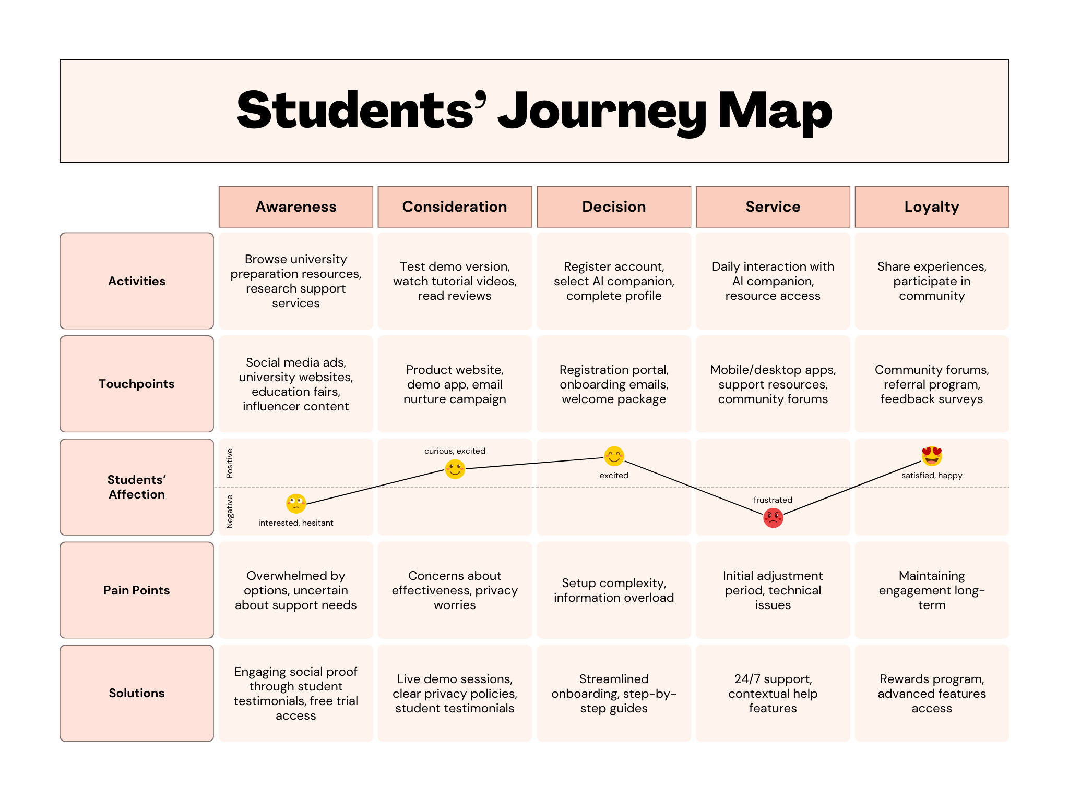

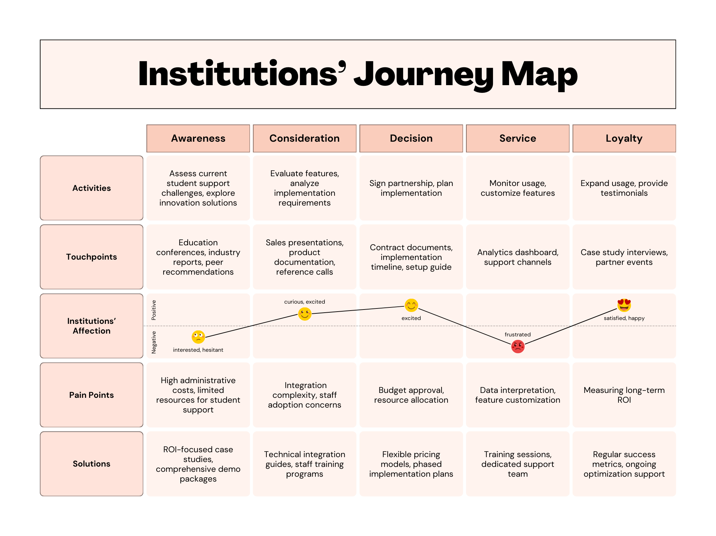

Our customer journey prioritises institutional adoption to drive student engagement:

**1. Institutional Transformation**

* *Early Journey Focus*: Convert institutions through compelling ROI demonstrations, seamless integration plans, and comprehensive support
* Outcome: Position as essential partner for 15+ major universities through proven administrative efficiency

**2. Platform Innovation Leadership**

* *Mid Journey Focus*: Leverage institutional partnerships to showcase AI capabilities and customization
* Outcome: Universities become innovation champions, driving broader market adoption

**3. Student Success Ecosystem**

* *Scale Through Institutions*: Use university channels for student onboarding and community building
* Outcome: Accelerate toward 100,000+ users through trusted institutional networks

Key Strategy: Educational institutions serve as credible distribution channels, creating a trusted pathway for student adoption and sustained engagement.

# 4. Implementation Plan

## 4.1 Launch Strategy

### 4.1.1 Initial Steps

**Finalise and Customise Service Offerings:**

StudyPaws will focus on providing pre-arrival (AussieLIFE) learning packages that offer critical resources on mental health, financial management, housing rights, and career outcomes~~.~~ Integrate materials with the AI-powered virtual pet companions, Luna the Therapy Cat and Ziggy the Friendly Pup, to provide both practical and emotional support.

**Partnerships and Collaborations:**

* Partner with Australian universities to integrate the StudyPaws into pre-arrival packages for international postgraduates and build strong relationships with university administrators.
* Collaborate with mental health professionals and organisations to provide expert input and endorsement for the mental health support component.

**AI Integration:**

StudyPaws will deploy virtual pets powered by **Character.ai** for real-time emotional support. Integrate ChatGPT as a knowledge base for practical questions on topics such as visa regulations and financial management. Implement WithTherapy for continuous escalation to professional therapy when needed.

### 4.1.2 Key Milestones:

**Short-term: Service Development**

* Finalise the AussieLIFE packages with content that includes video lectures, quizzes, Q&A, and access to mental health support. Key topics like Australian labour laws, housing rights, and budgeting will be covered.
* Partner with pilot universities to introduce StudyPaws and demonstrate the value of the virtual pet companions, with ChatGPT (for content queries) and Character.ai (for emotional support).

**Mid-term: University Onboarding & Marketing**

* Develop targeted partnerships to integrate StudyPaws into university program. Customise the learning platform according to each institution’s needs.
* Launch co-branded webinars with partner universities, showcasing StudyPaws' role in boosting student retention, mental health support, and administrative relief.
* Onboard universities for full-scale adoption of the service.

**Long-term: Full-Service Launch**

Roll out the service to a wider audience of international postgraduates, offering customizable options for universities and multilingual support for students. Continue to monitor and refine the service.

**4.1.3** **Ongoing Support:**

* Establish a feedback loop with university administrators and students to continuously improve the platform and address emerging needs.
* Utilise the administrative dashboard to track student progress and concerns, allowing universities to adapt support services proactively.

## 4.2 Challenges & Solutions

**Challenge 1: Accessibility of Mental Health Services**

International students may face barriers to accessing traditional mental health services due to cultural differences, language barriers, and logistical challenges.

**Solution:** We will be designingthe pet companions supported with multilingual interactions and culturally sensitive content. Customise the AussieLIFE packages to incorporate culturally relevant information and communication styles**.**

**Challenge 2: Ensuring AI Tools Meet Mental Health Needs**

While AI tools ChatGPT and Character.ai offer valuable mental health resources, they may lack the depth required for more serious psychological issues.

**Solution:** Equip StudyPaws with escalation protocols, enabling the AI pets to detect when students might need more intensive support and connect them to professional therapists.

**Challenge 3: Customisation and Scalability for different Universities**

Each university may have different needs for their international student support programs, which could create challenges in scaling StudyPaws’ offerings.

**Solution:** Offer customizable course packages that allow universities to modify content according to their specific service and student demographics. AI-driven administrative tools will help universities manage course customization.

**Challenge 4: Data Privacy and Security**

Handling sensitive student data, especially related to mental health, requires strict data privacy and security measures.

**Solution:** Implement robust data security protocols including encryption, and anonymization. We will clearly communicate to students how their data is managed and ensure transparency regarding data sharing with third-party services when connecting students to professional help.

# 5. Evaluation

## 5.1 Success metrics

Regarding success metrics, StudyPaws will focus on evaluating (1) engagement, (2) user satisfaction, and (3) well-being impact.

**Engagement (1)** is measured using the Balanced Scorecard framework, focusing on *login frequency*, *session duration*, and *feature use*. Daily Active Users (DAU) and Monthly Active Users (MAU) provide insight into user activity levels (Jiang et al., 2021), with a target of 70% retention within the first 90 days. The average session duration goal is 15–20 minutes, reflecting meaningful user interaction with StudyPaws resources.

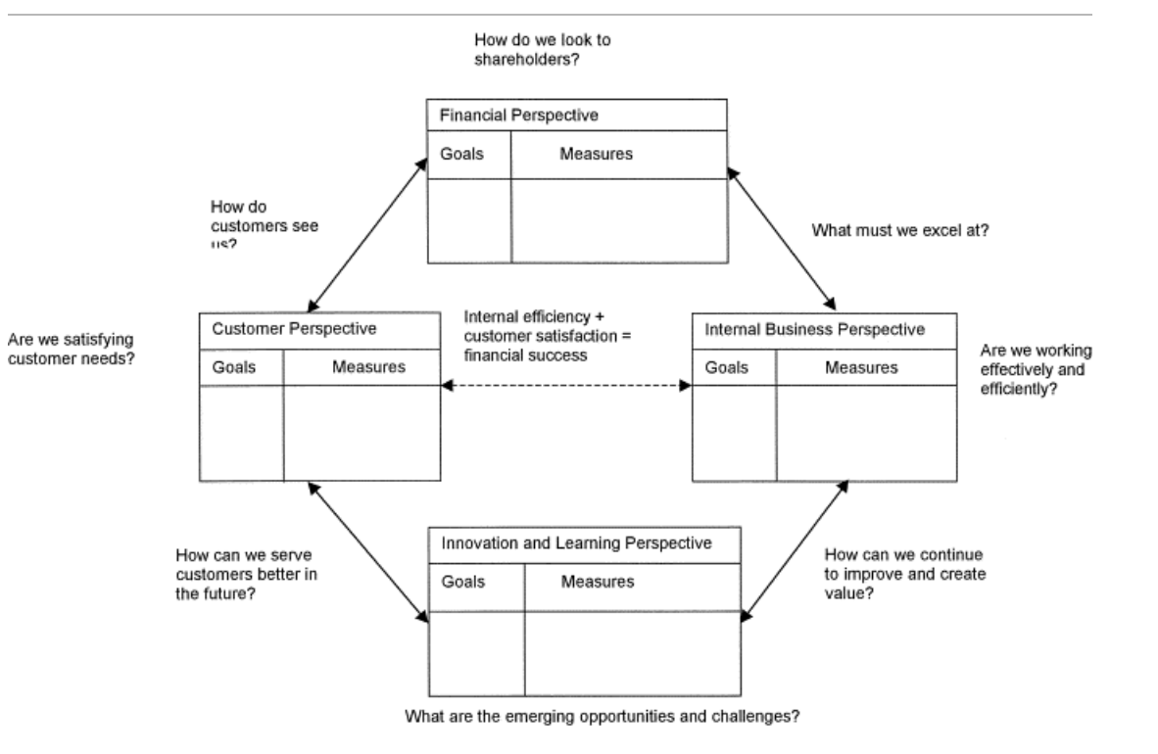

Balanced Scorecard framework (Martinsons et al., 1999)

StudyPaws will value **user satisfaction (2)** primarily through the Net Promoter Score (NPS), with a target score of 20 or higher to indicate strong satisfaction and engagement. After each interaction, students will rate their likelihood of recommending StudyPaws, and additional qualitative feedback on features like emotional support and pet customization will help refine the platform to better meet user needs. This focus on NPS and targeted feedback allows for streamlined data collection and actionable insights to continuously improve user experience.

To **measure well-being impact (3)**, StudyPaws will use the Warwick-Edinburgh Mental Wellbeing Scale (WEMWBS), aiming for a 10% improvement in emotional wellness within six months (Stewart-Brown and Janmohamed, 2008). Partner universities will track *retention* and *adaptation outcomes*, targeting a 5-10% increase in retention and a 20% decrease in issues related to independent living and cultural adaptation. These metrics align with Kirkpatrick Model Levels 3 and 4, emphasising behavioural impact and long-term outcomes.

## 5.2 Feedback Mechanism

StudyPaws will gather feedback by leveraging **(1) anonymous surveys** (focusing on quantitative data including engagement, user satisfaction metrics, and the WEMWBS) and **(2) optional interviews** (focusing on qualitative data such as well-being impact insights), which allows business to collect comprehensive insights from our users while prioritising user privacy.

**Anonymous surveys** will collect data across all three key metrics: (1) engagement tracking through usage patterns (DAU/MAU, session duration), (2) user satisfaction via post-interaction NPS ratings, and (3) well-being impact using WEMWBS. In-app questionnaires will appear after key interactions, featuring both quantitative metrics and optional open-ended questions, while comprehensive semester surveys via email/notifications will assess deeper aspects like retention and adaptation outcomes. To encourage participation, students will also receive small incentives, such as digital accessories for their virtual pets.

Moreover, **optional interviews** such as focus group interviews and one-on-one interviews will be available for students who wish to offer more personal, in-depth feedback. These optional, anonymous virtual interviews will cover a range of topics, including user experience, emotional wellness support, and recommendations for platform enhancements. Hence, students will be able to share their individual experiences and insights in detail, providing our team with nuanced perspectives that may not surface in broader surveys or group settings. This qualitative approach is crucial for understanding well-being impact, which is inherently difficult to quantify, while also revealing new user insights and addressing potential biases in survey data.

# References

Baker, K. L., Perkins, J., & Comber, D. P. (2014). International students and their experiences of Personal Development Planning. *Active Learning in Higher Education*, *15*(2), 129–143. https://doi.org/10.1177/1469787414527388

Bhale, U. (2024). *Study of Customer Satisfaction: Demographics and Level of Engagement Influence on Net Promoter Score (NPS)*. https://doi.org/10.2139/ssrn.4863052

Brenner, B. (2024, July 17). *Using AI to Connect You with the Right Therapist*. WithTherapy. https://withtherapy.com/therapist-insights/using-ai-to-connect-you-with-the-right-therapist/

Devane, H. (2022, May 13). *What Are the Top Data Anonymization Techniques?* Immuta. https://www.immuta.com/blog/data-anonymization-techniques/

Forbes-Mewett, H., & Sawyer, A.-M. (2011). *Mental Health Issues amongst International Students in Australia: Perspectives from Professionals at the Coal-face*. https://www.campusreview.com.au/wp-content/uploads/2011/11/Mental-Health-Issues-among-International-Students-in-Australia.pdf

Haque, M. R., & Rubya, S. (2022). An Overview of Chatbot Based Mobile Mental Health Applications: Insights from App Description and User Reviews (Preprint). *JMIR MHealth and UHealth*, *11*(11). https://doi.org/10.2196/44838

Jiang, F., Zheng, X., Fan, D., Zhang, P., & Li, S. (2021). The Sharing Economy and Business Model Design: A configurational approach. *Journal of Management Studies*, *58*(4), 949–976. https://doi.org/10.1111/joms.12711

Luna, E. (2023, May 22). *Character.AI: What it is and how to use it*. Mashable. https://mashable.com/article/character-ai-generator-explained

Martin, F. (2020). *Chinese international students’ wellbeing in australia: The road to recovery*. https://api.semanticscholar.org/CorpusID:229553464

Martinsons, M., Davison, R., & Tse, D. (1999). The balanced scorecard: A foundation for the Strategic Management of Information Systems. *Decision Support Systems*, *25*(1), 71–88. https://doi.org/10.1016/s0167-9236(98)00086-4

Oduwaye, O., Kiraz, A., & Sorakın, Y. (2023). A Trend Analysis of the Challenges of International Students Over 21 Years. *SAGE Open*, *13*(4). https://doi.org/10.1177/21582440231210387

Parsons, T. A. (2000). *Retaining international students : identifying the needs of international students attending Memorial University of Newfoundland*. https://api.semanticscholar.org/CorpusID:68141922

Pea, R. D. (1987). User centered system design: new perspectives on human-computer interaction. *Journal educational computing research*, *3*, 129-134.

Scott, E. (2024). *International students face major mental health barriers. Are universities doing enough?* SBS News. https://www.sbs.com.au/news/article/international-students-face-major-mental-health-barriers-are-universities-doing-enough/bxqzq6qsu

Shah, A. A., Lopes, A., & Kareem, L. (2019). Challenges faced by International students at Kwantlen Polytechnic University. *International Journal of Multidisciplinary Perspectives in Higher Education*, *4*(1), 111–135. https://doi.org/10.32674/jimphe.v4i1.1408

Stewart-Brown, S., & Janmohamed, K. (2008). Warwick-Edinburgh mental well-being scale. *User guide. Version*, *1*(10.1037).

Stumpf, S., Rajaram, V., Li, L., Burnett, M., Dietterich, T., Sullivan, E., Drummond, R., & Herlocker, J. (2007). Toward harnessing user feedback for Machine Learning. *Proceedings of the 12th International Conference on Intelligent User Interfaces*, 82–91. https://doi.org/10.1145/1216295.1216316

Zhang, T., Schoene, A. M., Ji, S., & Ananiadou, S. (2022). Natural language processing applied to mental illness detection: a narrative review. *Npj Digital Medicine*, *5*(1). https://doi.org/10.1038/s41746-022-00589-7

# 